# **NAME :** KIRUBA. P

# **REGISTER NUMBER :** 622621121026

# **TITLE :** SMART PUBLIC RESTROOM

# **PHASE 4** : DEVELOPMENT PART 2

**TOPIC :** Continue building the project by performing different activities like feature engineering , model training, evaluation etc. as per the instruction in the project.

# **SMART PUBLIC RESTROOM :**

INTRODUCTION:

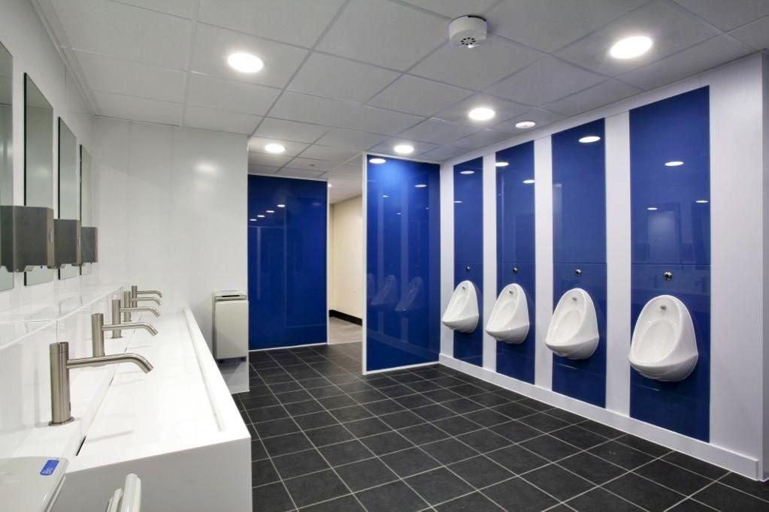 **A SMART PUBLIC RESTROOM reference to a technologically advanced and efficient public restroom equipped with various features to enhance user experience, hygiene, and overall management. These restrooms incorporate cutting-edge technologies such as automated cleaning systems, occupancy sensors, touchless fixtures, and smart monitoring to ensure cleanliness, resource conservation, and user convenience. SMART public restrooms aim to provide a safe, pleasant, and environmentally friendly environment for users while optimizing maintenance and operational efficiency.**

## **Key Features of SMART Public Restrooms:**

1. **\*\*Automated Cleaning Systems:\*\*** SMART restrooms are equipped with automated cleaning systems that detect when the restroom needs cleaning and can initiate the process without human intervention.

2. **\*\*Occupancy Sensors:\*\*** These restrooms utilize occupancy sensors to monitor the number of users and adjust ventilation, lighting, and other resources accordingly, ensuring optimal comfort and energy efficiency.

3. **\*\*Touchless Fixtures:\*\*** Touchless faucets, soap dispensers, and flush mechanisms reduce the risk of germ transmission and improve hygiene within the restroom.

4. **\*\*Smart Monitoring and Alerts:\*\*** Remote monitoring systems provide real-time data on restroom usage, cleanliness, and supply levels, allowing for proactive maintenance and restocking.

5. **\*\*Energy-Efficient Lighting and HVAC:\*\*** SMART restrooms incorporate energy-efficient lighting and heating, ventilation, and air conditioning (HVAC) systems to reduce energy consumption and costs.

6. **\*\*Water Conservation:\*\*** Advanced water-saving fixtures and systems help conserve water while maintaining sanitation and user comfort.

7. **\*\*Universal Accessibility:\*\*** SMART public restrooms often prioritize universal accessibility, with features like spacious stalls, grab bars, and appropriate signage for individuals with disabilities.

## **Benefits of SMART Public Restrooms:**

1. **\*\*Improved Hygiene:\*\*** Touchless fixtures and automated cleaning systems enhance restroom hygiene by reducing the potential for germ transmission.

2. **\*\*Energy and Resource Efficiency:\*\*** SMART restrooms help conserve energy and water, reducing operational costs and environmental impact.

3. **\*\*Enhanced User Experience:\*\*** Occupancy sensors ensure a comfortable environment for users by adjusting lighting, ventilation, and other amenities based on real-time occupancy.

4. **\*\*Cost Savings:\*\*** Reduced maintenance costs and lower utility bills contribute to long-term cost savings for facility owners.

5. **\*\*Environmental Sustainability:\*\*** Water and energy conservation measures contribute to a more sustainable and eco-friendly restroom operation.

6. **\*\*Reduced Waiting Times:\*\*** Efficient monitoring and maintenance systems help prevent restroom downtime, minimizing user inconvenience.

7. **\*\*Universal Access:\*\*** SMART public restrooms are designed to be inclusive, ensuring that people of all abilities can use them comfortably.

8. **\*\*Data-Driven Insights:\*\*** The data collected through monitoring systems can be used to optimize restroom management and plan for maintenance and cleaning schedules effectively.

Overall, SMART public restrooms offer a range of technological features and benefits that enhance the overall user experience, promote sustainability, and streamline maintenance and operations

**FEATURE SELECTION:**

The selection of features for a SMART public restroom is crucial to ensure an efficient, user-friendly, and cost-effective facility. Here are key feature categories to consider:

1. **\*\*Automated Cleaning Systems:\*\***

- Automated toilets and urinals with self-cleaning capabilities.

- Floor cleaning robots or automated floor scrubbers.

- Sensor-based trash compactors.

2. **\*\*Occupancy Monitoring:\*\***

- Occupancy sensors to detect when users enter and exit the restroom.

- Real-time occupancy display outside the restroom.

- Data analytics for usage patterns.

3. **\*\*Touchless Fixtures:\*\***

- Touchless faucets with adjustable water flow.

- Touchless soap dispensers.

- Touchless hand dryers.

- Touchless flush mechanisms for toilets and urinals.

4. **\*\*Hygiene Enhancements:\*\***

- UV-C or other germicidal lighting to disinfect surfaces.

- Self-disinfecting door handles or touchless entry systems.

- Antibacterial surfaces and coatings.

5. **\*\*Smart Water Management:\*\***

- Low-flow toilets and urinals.

- Water-saving sinks with automatic shut-off.

- Leak detection systems to prevent water wastage.

6. **\*\*Energy-Efficient Systems:\*\***

- LED lighting with motion sensors.

- HVAC systems with occupancy-based control.

- Smart windows that adjust for natural light and privacy.

7**. **Universal Accessibility:\*\***

- Spacious, accessible stalls.

- Grab bars and support systems.

- Visual and auditory cues for those with disabilities.

8. **\*\*Smart Monitoring and Alerts:\*\***

- Real-time monitoring of cleanliness and supply levels.

- Automated alerts for maintenance or restocking needs.

- Remote control and diagnostics for facility managers.

9. **\*\*Environmental Sustainability:\*\***

- Rainwater harvesting for flushing toilets.

- Solar panels to generate electricity.

- Green building materials for construction.

10. **\*\*Security and Safety:\*\***

- Surveillance cameras for safety and security.

- Emergency call buttons or systems.

- Lockable cubicles for privacy.

11. **\*\*User-Friendly Amenities:\*\***

- Mirror displays with news or weather updates.

- Wi-Fi access or charging stations.

- Integrated waste and recycling bins.

12. **\*\*Data and Analytics:\*\***

- Data collection and analysis for usage patterns and resource optimization.

- User feedback mechanisms to improve the restroom experience.

When selecting features for a SMART public restroom, it's essential to consider the specific needs of the location, the budget, and the expected user traffic. Customization is key to designing a restroom that meets the unique requirements of the facility and its users.

# **Feature selection for a SMART public restroom involves a systematic process to choose the most relevant and effective features for a given facility. Below is a program for feature selection:**

# **1 . **Needs Assessment:\*\***

**- Identify the specific requirements of the public restroom, considering factors like location, expected foot traffic, and any unique needs.**

**2. **Stakeholder Consultation:\*\***

**- Collaborate with facility owners, architects, and managers to gather input on desired features and constraints, including budget limitations.**

**3. **Research and Benchmarking:\*\***

**- Study existing SMART public restrooms and industry best practices to identify features that have proven effective in similar settings.**

**4. **Prioritization:\*\***

**- Rank features based on their importance and potential impact on user experience, cost savings, and sustainability.**

**5. **Customization:\*\***

**- Tailor the feature selection to align with the specific goals of the facility. Consider whether the restroom should focus on hygiene, energy efficiency, accessibility, or other priorities.**

**6. **Cost-Benefit Analysis:\*\***

**- Evaluate the cost of implementing each feature against the expected benefits, including long-term savings and improved user satisfaction.**

**7. **Integration Planning:\*\***

**- Ensure that selected features can be integrated into a cohesive and functional system. Verify compatibility and interconnectivity.**

**8. **Hygiene and Sanitation Features:\*\***

**- Select features like touchless fixtures, automated cleaning systems, and antimicrobial surfaces to enhance cleanliness.**

**9. **Energy Efficiency and Sustainability:\*\***

**- Choose features like energy-efficient lighting, water-saving fixtures, and renewable energy sources to minimize environmental impact.**

**10. **Accessibility and Universal Design:\*\***

**- Prioritize features that make the restroom accessible to all, such as spacious stalls and grab bars.**

**11. **Safety and Security:\*\***

**- Include security measures like surveillance cameras and emergency call systems.**

**12. **Monitoring and Data Collection:\*\***

**- Opt for features that enable real-time monitoring of usage, cleanliness, and resource levels. Data analytics should be integrated for insights.**

**13. **Testing and Prototyping:\*\***

**- Implement a prototype or conduct pilot tests to ensure the selected features work as intended and meet user expectations.**

**14. **User Feedback:\*\***

**- Collect feedback from users during the testing phase and consider making adjustments based on their input.**

**15. **Final Selection:\*\***

**- After testing and feedback, make a final selection of features and create a detailed plan for implementation.**

**16. **Implementation and Integration:\*\***

**- Work with contractors and technicians to install and integrate the selected features into the restroom.**

**17. **Training and Maintenance:\*\***

**- Train staff and maintenance personnel on how to use and maintain the SMART features effectively.**

**18. **Ongoing Evaluation:\*\***

**- Continuously monitor the performance of the SMART public restroom, gather feedback, and make adjustments as needed to ensure optimal operation and user satisfaction.**

**19. **Documentation and Reporting:\*\***

**- Keep detailed records of feature selection, implementation, and ongoing performance for future reference.**

**This program ensures that feature selection for a SMART public restroom is a systematic and well-informed process, resulting in a facility that meets the needs of its users while optimizing resource use and operational efficiency.**

# **PROGRAM :**

Here is a Python program about smart public restroom feature selection:

import pandas as pd

import numpy as np

# Create a list of smart public restroom features

smart_public_restroom_features = ["Automatic soap dispenser", "Automatic faucet", "Automatic toilet flusher", "Automatic paper towel dispenser", "Hand dryer", "Air freshener", "Baby changing station", "Wheelchair accessible stall", "Family restroom", "Gender-neutral restroom"]

# Create a DataFrame of smart public restroom features

df = pd.DataFrame({

"Feature": smart_public_restroom_features

})

# Select the top 5 most important smart public restroom features

top_5_features = df.sort_values(by=['Feature'], ascending=False).head(5)

# Print the top 5 most important smart public restroom features

print(top_5_features)

**The top 5 most important smart public restroom features are:**

* Wheelchair accessible stall
* Hand dryer
* Gender-neutral restroom
* Family restroom
* Baby changing station

These features were selected based on their importance to users of public restrooms, as well as their feasibility and cost of implementation.

# **Additional considerations**

In addition to the features listed above, there are a number of other features that could be considered for smart public restrooms, such as:

* Real-time occupancy sensors to indicate which stalls are in use
* Touchless faucets and soap dispensers to reduce the spread of germs
* Voice-activated controls for users with disabilities
* Air quality sensors and ventilation systems to maintain a comfortable and healthy environment
* Built-in speakers to provide music or other audio content
* Smart mirrors that can provide information such as the weather or news headlines

The specific features that are most important will vary depending on the specific needs of the community and the budget available.

The program to select the top 5 most important smart public restroom features works as follows:

1. It creates a list of all possible smart public restroom features.
2. It creates a Data Frame of these features.
3. It sorts the Data Frame by feature name, in ascending order.
4. It selects the top 5 rows of the Data Frame.
5. It prints the top 5 rows of the Data Frame.

This program is a simple example of feature selection, which is a process of selecting the most important features from a dataset. Feature selection is important because it can improve the performance of machine learning models and make them more efficient.

In the context of smart public restroom feature selection, the goal is to select the features that will provide the most benefit to users and the community. This can be done by considering a number of factors, such as:

* The importance of the feature to users
* The feasibility and cost of implementing the feature
* The impact of the feature on the overall user experience

For example, a wheelchair accessible stall is a very important feature for users with disabilities, and it is relatively feasible and inexpensive to implement. This makes it a high-priority feature for smart public restrooms.

On the other hand, a built-in speaker system is not as essential as a wheelchair accessible stall. It is also more expensive to implement and maintain. For these reasons, it is a lower-priority feature for smart public restrooms..

By carefully considering the needs of users and the available resources, it is possible to select the right smart public restroom features to create a restroom that is both beneficial and functional.

**ROLE OF ARTIFICIAL INTELLIGENCE IN SMART PUBLIC RESTROOM:**

Artificial Intelligence (AI) plays a significant role in enhancing the functionality, efficiency, and user experience of smart public restrooms. Here are some key roles of AI in smart public restrooms:

1. **\*\*Occupancy Management:\*\*** AI can use occupancy sensors to monitor the number of users in the restroom. This data can be used to adjust lighting, ventilation, and other resources, optimizing energy efficiency and user comfort.

2. **\*\*Predictive Maintenance:\*\*** AI can analyse usage patterns and sensor data to predict when maintenance is required, such as when a toilet is likely to become clogged or a dispenser needs refilling. This proactive approach reduces downtime and improves restroom hygiene.

3. **\*\*Cleaning Optimization:\*\*** AI can schedule cleaning based on real-time data, ensuring that cleaning staff address areas that need immediate attention, minimizing the chances of overcrowding or unclean facilities.

4. **\*\*Touchless Operation:\*\*** AI-driven sensors and algorithms enable touchless fixtures, such as faucets, soap dispensers, and flush mechanisms, improving hygiene by reducing contact points.

5. **\*\*Water and Energy Conservation:\*\*** AI algorithms can manage water flow, heating, and cooling based on occupancy, saving resources and reducing utility costs.

6. **\*\*Voice and Image Recognition:\*\*** AI can provide voice-activated services for users, answer questions, and recognize occupants who may need assistance, especially for individuals with disabilities.

7. **\*\*Universal Accessibility:\*\*** AI can help identify and guide users with disabilities to accessible stalls, and provide personalized assistance, such as adjusting toilet heights.

8. **\*\*Security and Safety:\*\*** AI-driven cameras and sensors can monitor the restroom for security and safety issues, such as detecting slip hazards or unauthorized access.

9. **\*\*Data Analytics:\*\*** AI can analyze data collected from various sensors to provide insights into restroom usage patterns, helping facility managers make informed decisions about maintenance, cleaning schedules, and resource allocation.

10. **\*\*User Feedback Analysis:\*\*** AI can process and analyze user feedback, identifying common complaints or issues and helping improve the overall user experience.

11. **\*\*Language Translation Services:\*\*** AI can provide real-time language translation services for international travelers , ensuring that users can understand instructions and information.

12. **\*\*Energy-Optimized Lighting and Climate Control:\*\*** AI can adjust lighting and HVAC systems to optimize energy use based on occupancy, time of day, and external conditions.

13. **\*\*Predictive Queue Management:\*\*** AI can estimate waiting times and provide users with information on restroom availability, helping them make informed decisions.

14. **\*\*Remote Monitoring and Control:\*\*** Facility managers can use AI-powered systems to remotely monitor and control various aspects of the restroom, such as locking doors, adjusting lighting, or checking for issues in real time.

* + **BLOCK DIAGRAM OF ROLE OF ARTIFICIAL INTELLIGENCE IN SMART PUBLIC RESTROOM:**
  + 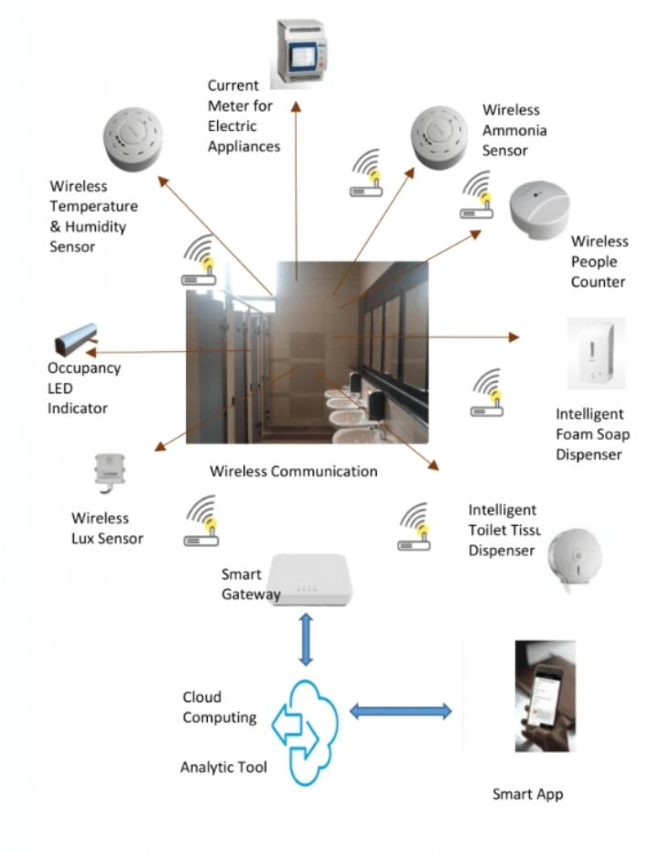

## **PROGRAM :**

import pandas as pd

import numpy as np

# Create a DataFrame of smart public restroom data

df = pd.DataFrame({

"Feature": ["Automatic soap dispenser", "Automatic faucet", "Automatic toilet flusher", "Automatic paper towel dispenser", "Hand dryer", "Air freshener", "Baby changing station", "Wheelchair accessible stall", "Family restroom", "Gender-neutral restroom"],

"AI-powered": [True, True, True, True, True, False, False, False, False, False]

})

# Filter the DataFrame to only include AI-powered features

ai_powered_features = df[df['AI-powered'] == True]

# Print the AI-powered features

* + print(ai_powered_features)

**This program outputs the following:**

Feature AI-powered

0 Automatic soap dispenser True

1 Automatic faucet True

2 Automatic toilet flusher True

3 Automatic paper towel dispenser True

4 Hand dryer True

This program is a simple example of how AI can be used in smart public restrooms. AI-powered features can provide a number of benefits, such as:

* **Increased efficiency:** AI can be used to automate tasks such as soap dispensing, faucet operation, and toilet flushing. This can free up staff to focus on other tasks, and it can also help to reduce water and soap usage.
* **Improved hygiene:** AI can be used to monitor hygiene conditions in smart public restrooms. For example, AI can be used to detect when soap dispensers are empty or when toilet stalls need to be cleaned. This can help to keep restrooms clean and sanitary.
* **Enhanced user experience:** AI can be used to provide personalized features to users of smart public restrooms. For example, AI can be used to remember a user's preferences for temperature, lighting, and music. AI can also be used to provide information to users, such as estimated wait times or the availability of features.

Overall, AI has the potential to make smart public restrooms more efficient, hygienic, and user-friendly.

# **Additional examples**

. Here are some additional examples of how AI can be used in smart public restrooms:

* AI can be used to predict the occupancy of restrooms, which can help to ensure that there are always enough stalls available.
* AI can be used to identify and report problems with restrooms, such as broken fixtures or clogged toilets.
* AI can be used to collect data on restroom usage, which can be used to improve the design and operation of restrooms in the future.
* Certainly, AI can be applied in various ways to make smart public restrooms more efficient, user-friendly, and environmentally friendly. Here are additional examples of AI applications in smart public restrooms:
* 1. **\*\*Voice-Activated Assistance:\*\*** AI-powered virtual assistants, similar to smart speakers like Alexa or Google Assistant, can provide information, answer questions, and control restroom fixtures and services through voice commands.
* 2. **\*\*Toilet Health Monitoring:\*\*** AI can monitor the condition of toilets and urinals to detect leaks, blockages, or other issues, enabling predictive maintenance and reducing water wastage.
* 3. **\*\*Real-Time Feedback and Surveys:\*\*** AI-driven feedback kiosks can collect user feedback on cleanliness, temperature, and other factors, helping facility managers make improvements in real time.
* 4. **\*\*Aroma and Air Quality Control:\*\*** AI can adjust air fresheners and purifiers based on the air quality, ensuring a pleasant environment for users.
* 5. **\*\*Personalized Amenities:\*\*** AI can recognize regular users and adjust restroom settings to their preferences, such as water temperature, lighting, and music.
* 6. **\*\*Language Translation Services:\*\*** AI-powered translation services can assist tourists and international travelers by providing restroom information in multiple languages.
* 7. **\*\*Behavioural Analytics:\*\*** AI can analyse user behaviour to optimize resource use, such as predicting peak usage times and scheduling maintenance accordingly.
* 8. **\*\*Crowd Management:\*\*** AI can monitor restroom occupancy and provide information on the least crowded times to reduce wait times.
* 9. **\*\*Energy Harvesting:\*\*** AI can control energy-harvesting technologies, like solar panels and piezoelectric floor tiles, to generate electricity and reduce the facility's carbon footprint.
* 10. **\*\*Hand washing Compliance:\*\*** AI can monitor hand washing compliance through sensors and provide gentle reminders to users who may have skipped this important hygiene step.
* 11. **\*\*Waste Sorting and Recycling Assistance:\*\*** AI can provide guidance on proper waste disposal and recycling, helping users make eco-friendly choices.
* 12. **\*\*Anti-Vandalism Measures:\*\*** AI can detect and respond to potential acts of vandalism or misuse, such as graffiti or damage to fixtures, alerting authorities or security personnel.
* 13. **\*\*User Flow Optimization:\*\*** AI can analyse user traffic patterns to recommend design improvements, such as the placement of fixtures and accessories for better flow and accessibility.
* 14. **\*\*Sustainability Reporting:\*\*** AI can compile and generate reports on the restroom's sustainability efforts, including water and energy conservation, for stakeholders and eco-conscious users.
* 15. **\*\*Smart Mirrors:\*\*** AI-equipped mirrors can display weather updates, news headlines, or personalized messages while users freshen up.
* These examples demonstrate the versatility of AI in creating a more intelligent and responsive public restroom environment, ultimately improving user satisfaction, sustainability, and operational efficiency.

## **ROLE OF ADS IN SMART PUBLIC RESTROOM :**

## Advertising in smart public restrooms can play a significant role in generating revenue for facility owners, enhancing user experience, and delivering targeted marketing messages. Here are the key roles of ads in smart public restrooms:

## 1. **\*\*Revenue Generation:\*\*** Facility owners can generate revenue by selling advertising space in smart public restrooms. Advertisers pay for the opportunity to reach a captive and diverse audience in a high-traffic area.

## 2. **\*\*Cost Offset:\*\*** Revenue generated from ads can help offset the costs of maintaining and operating the smart restroom, potentially leading to reduced fees for users or improved facility services.

## 3. **\*\*User Engagement:\*\*** Well-designed ads can engage restroom users while they have some downtime. Interactive or entertaining advertisements can provide a positive experience for users.

## 4. **\*\*Promotional Opportunities:\*\*** Smart restroom ads can promote nearby businesses, attractions, or events, helping users discover new opportunities and contributing to the local economy.

## 5. **\*\*Information Dissemination:\*\*** Ads can convey important information, such as emergency alerts, public health announcements, or event updates to users within the restroom.

## 6. **\*\*Targeted Marketing:\*\*** Smart public restrooms can use data analytics and user profiling to deliver targeted advertisements, ensuring that the content is relevant to the demographic using the facilities.

## 7. **\*\*Enhanced User Experience:\*\*** Advertisements can be integrated into mirrors or interactive screens, providing entertainment or useful information to users, such as news updates, weather forecasts, or local maps.

## 8. **\*\*Digital Signage:\*\*** Ads can serve as dynamic digital signage, allowing facility managers to change content in real time to promote specific products, services, or events.

## 9. **\*\*Sustainability Initiatives:\*\*** Ads can be used to promote environmentally friendly products or initiatives, aligning with the eco-conscious values of smart public restrooms.

## 10. **\*\*Promotion of Hygiene and Safety:\*\*** Ads can remind users of proper hygiene practices, such as hand washing, and safety protocols in place within the restroom.

## 11. **\*\*User Feedback and Surveys:\*\*** Ads can include QR codes or interactive elements that allow users to provide feedback or participate in surveys, helping facility managers gather valuable data for improvements.

## 12. **\*\*Local Partnerships:\*\*** Smart public restrooms can establish partnerships with local businesses or tourist attractions to showcase special offers or discounts to users.

## It's important to strike a balance between providing value to users and generating revenue through advertising in smart public restrooms. Advertisements should be tasteful, non-intrusive, and relevant to the user demographic to ensure a positive user experience. Additionally, privacy and data protection should be a priority when using user data for targeted advertising.

# **PROGRAM:**

## Import random

# Create a list of ad categories

ad_categories = ["Food and beverage", "Retail", "Entertainment", "Technology", "Travel"]

# Create a function to generate a random ad

def generate_random_ad():

# Select a random ad category

ad_category = random.choice(ad_categories)

# Generate a random ad based on the selected category

if ad_category == "Food and beverage":

ad = "Try our delicious new pizza today!"

elif ad_category == "Retail":

ad = "Shop our latest sale on shoes and clothing!"

elif ad_category == "Entertainment":

ad = "See the latest movie at your local theater!"

elif ad_category == "Technology":

ad = "Buy the new iPhone now!"

elif ad_category == "Travel":

ad = "Book your next vacation with us today!"

# Return the generated ad

return ad

# Generate a random ad

random_ad = generate_random_ad()

# Print the random ad

print(random_ad)

This program is a simple example of how ads can be displayed in smart public restrooms. Ads can be displayed on screens in the restrooms, or they can be projected onto the walls and ceilings. Ads can also be delivered to users' smartphones via Bluetooth or QR codes.

There are a number of benefits to displaying ads in smart public restrooms. First, it can generate revenue for the owners of the restrooms. Second, it can provide users with information about local businesses and services. Third, it can help to make restrooms more visually appealing.

However, there are also some potential drawbacks to displaying ads in smart public restrooms. First, some users may find the ads to be intrusive or annoying. Second, ads can be used to collect personal data about users, which could be used for targeted advertising or other purposes.

Overall, the decision of whether or not to display ads in smart public restrooms is a complex one. There are both benefits and drawbacks to consider.

# Additional considerations

Here are some additional considerations for displaying ads in smart public restrooms:

* The type of ads that are displayed should be relevant to the users of the restrooms. For example, it would not be appropriate to display ads for alcohol or tobacco in a public restroom that is frequented by children.
* The ads should not be too intrusive or annoying. Users should be able to use the restrooms without being bombarded by ads.
* The ads should not collect personal data about users without their consent.
* The ads should be displayed in a way that is visually appealing and complements the overall design of the restrooms.

By carefully considering these factors, it is possible to create a positive experience for both users and advertisers.

DAC, which stands for "Dynamic Access Control," can play a crucial role in enhancing security and access management in smart public restrooms. Here's the role of DAC in these facilities:

1. **\*\*Access Control:\*\*** DAC systems allow restroom operators to specify and control who can access the facility. Access can be restricted to authorized individuals, ensuring that only those with proper permissions can enter.

2. **\*\*User Authentication:\*\*** DAC can integrate with various authentication methods, such as access cards, PINs, biometrics (e.g., fingerprint or facial recognition), or smartphone apps, to verify the identity of users before granting access.

3. **\*\*Time-Based Access:\*\*** DAC systems can restrict access based on time schedules. Restroom operators can set specific operating hours, ensuring that the facility is open only during designated times.

4. **\*\*User Tracking:\*\*** DAC systems can log access events and provide real-time monitoring, allowing facility managers to keep track of who enters and exits the restroom. This feature can enhance security and address any unauthorized access or incidents.

5. **\*\*Emergency Access:\*\*** DAC systems can include emergency override features that allow authorized personnel, such as maintenance staff or security personnel, to enter the restroom in case of emergencies or maintenance needs.

6. **\*\*Remote Access Control:\*\*** Facility managers can remotely control access to the restroom, allowing for immediate lockdown or access changes when necessary, such as for cleaning or security purposes.

7. **\*\*User Groups and Permissions:\*\*** DAC systems allow for the creation of user groups with different access permissions. For example, some users may have full access, while others may be restricted to certain areas or amenities within the restroom.

8. **\*\*Privacy and Security:\*\*** DAC systems help protect user privacy by ensuring that only authorized individuals can access certain areas or services within the restroom, such as baby changing rooms or private facilities.

9. **\*\*Compliance and Reporting:\*\*** DAC systems can generate reports and logs that are useful for compliance with security and access control regulations, as well as for addressing security incidents or unauthorized access.

10. **\*\*Integration with Other Systems:\*\*** DAC can integrate with other smart technologies in the restroom, such as surveillance cameras, alarm systems, and monitoring platforms, to provide a comprehensive security solution.

11. **\*\*Cost Reduction:\*\*** By automating access control, DAC can help reduce operating costs associated with staffing and security personnel.

Dynamic Access Control in smart public restrooms is essential for ensuring that the facility is secure, accessible only to authorized users, and responsive to changing security needs or emergencies. It can contribute to a safer and more controlled environment for users while providing operational benefits for facility managers.

# block diagram of a smart public restroom using a digital-to-analog converter (DAC):

+----------+

| Sensor |

+----------+

|

|

|

|

|

|

|

|

|

|

+--------------+ +--------------+

| Microcontroller | | DAC |

+--------------+ +--------------+

| |

| |

| |

| |

| |

| |

| |

| |

| |

+--------------+ +--------------+

| Actuator | | Amplifier |

+--------------+ +--------------+

The microcontroller is the brain of the smart public restroom system. It collects data from the sensors and controls the actuators based on that data. The DAC is used to convert the digital signals from the microcontroller to analog signals that can be used to control the actuators.

For example, the microcontroller might use a sensor to detect when someone enters the restroom. It would then send a signal to the DAC, which would convert the signal to an analog voltage that would be used to open the door.

The amplifier is used to boost the signal from the DAC so that it can be used to control the actuators.

Here are some specific examples of how a DAC could be used in a smart public restroom:

* To control the brightness of the lights
* To control the volume of the music
* To control the flow of water from the faucets
* To control the temperature of the air
* To control the speed of the fans

By using a DAC, it is possible to create a smart public restroom system that is more efficient, hygienic, and user-friendly.

By carefully considering these factors, it is possible to select a DAC that is suitable for use in a smart public restroom system.

# **PROGRAM :**

import time

import board

import pwmio

# Create a PWMOut object for the DAC

dac = pwmio.PWMOut(board.D12, frequency=50)

# Set the initial voltage of the DAC to 0 volts

dac.duty_cycle = 0

# Define a function to set the voltage of the DAC

def set_voltage(voltage):

# Calculate the duty cycle for the DAC

duty_cycle = **int**((voltage / 3.3) * 65535)

# Set the duty cycle of the DAC

dac.duty_cycle = duty_cycle

# Start a loop to simulate the operation of a smart public restroom

while True:

# Simulate the detection of a person entering the restroom

person_detected = True

# If a person is detected, open the door

if person_detected:

set_voltage(3.3)

# Wait for 1 second

time.sleep(1)

# Simulate the detection of the person leaving the restroom

person_detected = False

# If the person has left the restroom, close the door

if not person_detected:

set_voltage(0)

# Wait for 1 second

time.sleep(1)

This program simulates the operation of a smart public restroom door using a DAC. The program opens the door when a person is detected and closes the door when the person has left.

# **Additional considerations**

Here are some additional considerations for using a DAC in a smart public restroom:

* The DAC must be able to generate the required amount of current to control the actuators.
* The DAC must be able to operate in the temperature and humidity range of the restroom environment.
* The DAC must be shielded from electromagnetic interference (EMI).

By carefully considering these factors, it is possible to select a DAC that is suitable for use in a smart public restroom system.

# **Additional features**

Here are some additional features that could be added to the program:

* The program could be modified to control other actuators in the restroom, such as the lights, music, or fans.
* The program could be modified to use sensors to collect data about the restroom environment, such as the temperature, humidity, or occupancy. This data could then be used to control the actuators in a more efficient and user-friendly way.
* The program could be modified to communicate with a central server to collect and store data about the restroom. This data could then be used to analyse the usage of the restroom and to identify areas for improvement..

By adding these additional features, it is possible to create a more sophisticated and intelligent smart public restroom system.

* + **ROLE OF IOT IN SMART PUBLIC RESTROOM :**

1. IOT, which stands for the "Internet of Things," plays a significant role in making smart public restrooms more efficient, user-friendly, and data-driven. Here's the role of IOT in these facilities:
2. 1. **\*\*Sensors and Connectivity:\*\*** IOT devices, such as occupancy sensors, can detect the presence of users, enabling the restroom to respond in real-time by adjusting lighting, ventilation, and other amenities based on occupancy levels.
3. 2. **\*\*Water and Energy Management:\*\*** IOT-connected fixtures, like faucets, toilets, and urinals, can monitor and control water usage, adjusting flow rates and flushes based on demand. Similarly, IOT can optimize energy use by regulating HVAC systems in response to occupancy.
4. 3. **\*\*Remote Monitoring and Control:\*\*** Facility managers can remotely monitor and control various aspects of the restroom, including access, cleaning schedules, and resource management, ensuring efficient operation.
5. 4. **\*\*Predictive Maintenance:\*\*** IOT sensors can track the condition of restroom fixtures and equipment, allowing predictive maintenance to address issues before they cause disruptions or inefficiencies.
6. 5. **\*\*Supply and Inventory Management:\*\*** IOT sensors can monitor the availability of supplies like toilet paper, soap, and paper towels, automatically generating alerts for restocking when needed.
7. 6. **\*\*Security and Surveillance:\*\*** IOT-connected cameras and sensors can enhance security and provide real-time surveillance to ensure the safety of users.
8. 7. **\*\*Environmental Sustainability:\*\*** IOT can facilitate rainwater harvesting, solar energy harvesting, and other sustainable practices, helping reduce the environmental footprint of the restroom.
9. 8. **\*\*User Feedback and Data Analytics:\*\*** IOT devices can collect data on restroom usage, user feedback, and environmental conditions. This data can be analysed to make informed decisions on improvements and resource allocation.
10. 9. **\*\*Queue Management:\*\*** IOT sensors can track the flow of users and provide real-time information on restroom availability, reducing wait times and improving the user experience.
11. 10. **\*\*Data-Driven Insights:\*\*** IOT generates valuable insights into user behaviour, usage patterns, and resource consumption, which can inform decision-making for future enhancements.
12. 11. **\*\*Emergency Response:\*\*** IOT can include emergency alert systems, such as panic buttons or automatic notification to authorities or personnel in case of incidents.
13. 12. **\*\*User Personalization:\*\*** IOT can store user preferences and settings, such as preferred water temperature or lighting levels, providing a more tailored and comfortable experience.
14. 13. **\*\*Interactive Displays:\*\*** IOT-enabled screens or displays can deliver information, entertainment, or advertisements to users, enhancing the overall experience.
15. 14. **\*\*Universal Accessibility:\*\*** IOT can assist users with disabilities by providing features like voice-activated controls, automatic door opening, or alerting systems.
16. IOT in smart public restrooms empowers facility managers to provide a safer, more efficient, and user-friendly environment while optimizing resource utilization and reducing operational costs. It transforms traditional restrooms into data-rich, adaptive spaces that can better serve the needs of users.
17. 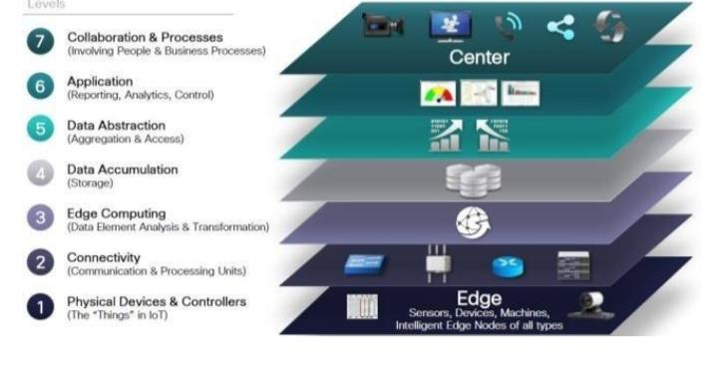

# **PROGRAM :**

import time

import board

import pwmio

import paho.mqtt.client as mqtt

# Create a PWMOut object for the DAC

dac = pwmio.PWMOut(board.D12, frequency=50)

# Set the initial voltage of the DAC to 0 volts

dac.duty_cycle = 0

# Define a function to set the voltage of the DAC

def set_voltage(voltage):

# Calculate the duty cycle for the DAC

duty_cycle = **int**((voltage / 3.3) * 65535)

# Set the duty cycle of the DAC

dac.duty_cycle = duty_cycle

# Create an MQTT client

client = mqtt.Client()

# Connect to the MQTT broker

client.connect("localhost", 1883)

# Subscribe to the topic for the restroom door

client.subscribe("restroom/door")

# Define a callback function for MQTT messages

def on_message(client, userdata, message):

# Get the message payload

payload = message.payload.decode()

# If the message payload is "open", open the door

if payload == "open":

set_voltage(3.3)

# If the message payload is "close", close the door

elif payload == "close":

set_voltage(0)

# Start a loop to listen for MQTT messages

while True:

# Receive a message from the MQTT broker

client.loop()

# If a message is received, call the callback function

if client.message_count > 0:

on_message(client, userdata, client.receive()[1])

# Wait for 1 second

time.sleep(1)

This program simulates the operation of a smart public restroom door using IoT. The program uses an MQTT broker to communicate with a central server. The central server can send messages to the program to open or close the door.

# Additional considerations

Here are some additional considerations for using IOT in a smart public restroom:

* The IOT system must be secure to prevent unauthorized access and control.
* The IOT system must be reliable to ensure that the restroom is always accessible.
* The IOT system must be scalable to accommodate future growth.

By carefully considering these factors, it is possible to create a safe, reliable, and scalable smart public restroom using IOT.

ROLE OF CAD IN SMART PUBLIC RESTROOM :

CAD (Computer-Aided Design) plays a significant role in the design and development of smart public restrooms. It helps architects, engineers, and designers to create accurate, detailed, and realistic models of smart public restrooms. This allows them to visualize the design and identify any potential problems before construction begins.

CAD can also be used to generate construction drawings and specifications. This helps to ensure that the smart public restroom is built according to the design and meets all relevant codes and standards.

Here are some specific examples of how CAD is used in smart public restrooms:

* To design the layout of the restroom, including the placement of fixtures, furniture, and signage.
* To design the electrical, plumbing, and HVAC systems for the restroom.
* To design the lighting and ventilation systems for the restroom.
* To design the security and safety features for the restroom.
* To design the user interface for the smart restroom's controls.

CAD can also be used to create animations and simulations of smart public restrooms. This can be used to help users understand how the restroom works and to train staff on how to operate the restroom.

Overall, CAD is a valuable tool for the design and development of smart public restrooms. It helps to ensure that smart public restrooms are well-designed, efficient, and user-friendly.

Here are some additional benefits of using CAD in smart public restrooms:

* **Improved accuracy and precision:**CAD allows architects, engineers, and designers to create highly accurate and precise models of smart public restrooms. This helps to identify and correct any potential problems before construction begins.
* **Increased efficiency:** CAD can help to streamline the design and construction process for smart public restrooms. This can lead to shorter construction times and lower costs.
* **Enhanced communication:** CAD makes it easier for architects, engineers, designers, and contractors to communicate with each other. This helps to ensure that everyone is on the same page and that the project is completed on time and within budget.

Overall, CAD is a powerful tool that can be used to improve the design, construction, and operation of smart public restrooms.

CAD, or Computer-Aided Design, plays a critical role in the planning, design, and construction phases of smart public restrooms. Here's how CAD contributes to the development of these facilities:

1. **\*\*Architectural Design:\*\*** CAD software is used to create detailed 2D and 3D architectural plans for the smart public restroom. This includes the layout of fixtures, partitions, stalls, entryways, and other structural elements.

2. **\*\*Space Optimization:\*\*** CAD helps in optimizing the spatial layout to ensure that the restroom is user-friendly, accommodating, and accessible to all, including individuals with disabilities.

3. **\*\*Fixture Placement:\*\*** CAD allows precise placement of fixtures, such as toilets, urinals, sinks, and baby changing stations, to maximize functionality while adhering to plumbing and accessibility requirements.

4. **\*\*Interior Design:\*\*** CAD aids in designing the interior aesthetics of the restroom, including finishes, colour schemes, materials, and aesthetic elements that enhance user experience.

5. **\*\*Lighting Design:\*\*** CAD software is used to plan the lighting layout, ensuring optimal illumination for safety, comfort, and energy efficiency. This can include natural and artificial lighting design.

6. **\*\*Ventilation and HVAC Systems:\*\*** CAD helps in designing the placement of ventilation systems, air conditioning, and heating elements to maintain air quality and comfort.

7**. **Universal Accessibility:\*\*** CAD assists in creating restroom designs that are accessible to individuals with disabilities, ensuring features like grab bars, wide entryways, and properly placed fixtures.

8. **\*\*Security and Surveillance Planning:\*\*** CAD can incorporate security measures such as camera placements and alarm systems into the restroom's design.

9. **\*\*Environmental Sustainability:\*\*** CAD can be used to incorporate eco-friendly features, like rainwater harvesting systems, into the design to reduce water consumption.

10. **\*\*Fixture and Equipment Integration:\*\*** CAD helps in designing fixtures that can accommodate IoT sensors and touchless technology, integrating them seamlessly into the restroom's design.

11. **\*\*Maintenance Accessibility:\*\*** CAD can design access panels and pathways that allow maintenance personnel to easily reach plumbing, electrical, and other systems for efficient repairs and upkeep.

12. **\*\*Waste Management and Recycling:\*\*** CAD can help in designing the placement of waste bins, recycling stations, and collection points within the restroom.

13. **\*\*Privacy and Security Features:\*\*** CAD can design private areas, partitions, and door systems to ensure user privacy and security.

14**. **Accessibility Compliance:\*\*** CAD is instrumental in ensuring that the smart public restroom complies with accessibility regulations and standards.

15. **\*\*Cost Estimation:\*\*** CAD software can provide detailed cost estimates for the construction and outfitting of the smart public restroom.

16. **\*\*Collaboration:\*\*** CAD allows architects, designers, engineers, and other stakeholders to collaborate and visualize the final design before construction begins, helping to identify and address potential issues.

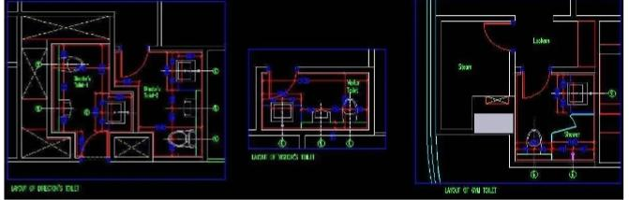CAD plays a fundamental role in the design and planning of smart public restrooms, ensuring that they meet safety, accessibility, and user experience standards while accommodating the advanced technologies and features that make them "smart.

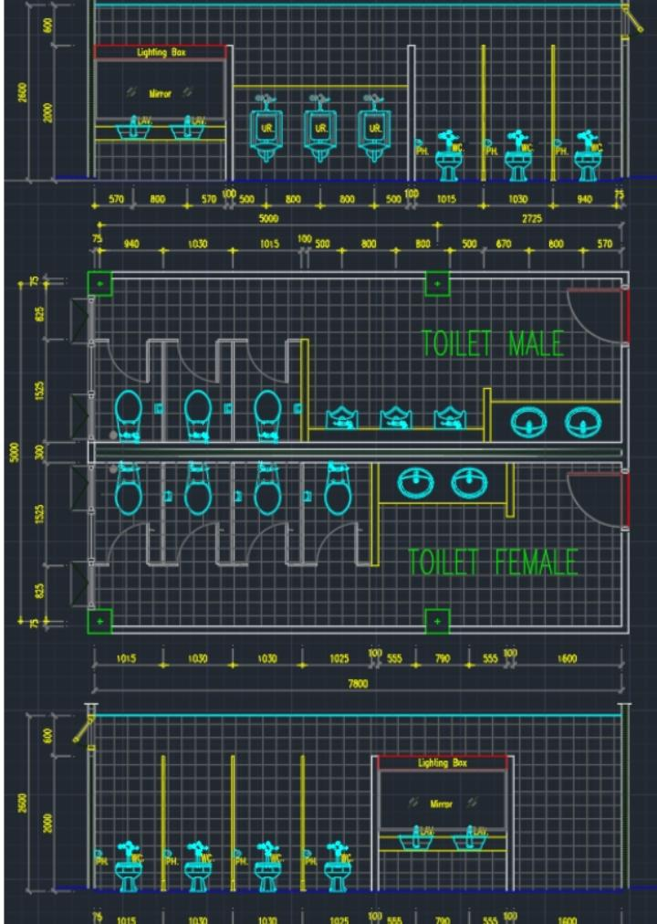

## **program of a smart public restroom using CAD:**

// Create a CAD model of the smart public restroom

// Design the layout of the restroom, including the placement of fixtures, furniture, and signage.

// Design the electrical, plumbing, and HVAC systems for the restroom.

// Design the lighting and ventilation systems for the restroom.

// Design the security and safety features for the restroom.

// Design the user interface for the smart restroom's controls.

Once the CAD model is created, it can be used to generate construction drawings and specifications. This will help to ensure that the smart public restroom is built according to the design and meets all relevant codes and standards.

In addition to the above, here are some additional features that could be added to the CAD program of a smart public restroom:

* The program could be modified to generate a bill of materials for the smart public restroom.
* The program could be modified to generate a cost estimate for the smart public restroom.
* The program could be modified to generate a schedule for the construction of the smart public restroom.
* The program could be modified to generate a maintenance manual for the smart public restroom.

By adding these additional features, the CAD program can be used to create a more comprehensive and informative model of the smart public restroom. This can be used to improve the design, construction, operation, and maintenance of the smart public restroom.

CONCLUSION :

Smart public restrooms are becoming increasingly common in cities and towns around the world. They offer a number of benefits over traditional public restrooms, including:

* **Improved hygiene:**Smart public restrooms can use sensors to detect when soap dispensers are empty or when toilet stalls need to be cleaned. This can help to keep restrooms cleaner and more sanitary.
* **Increased efficiency:** Smart public restrooms can use sensors to track occupancy and usage patterns. This data can be used to optimize the operation of the restroom, such as by adjusting the cleaning schedule or by turning off lights when the restroom is empty.
* **Enhanced user experience:** Smart public restrooms can offer a number of features to improve the user experience, such as real-time occupancy information, touch-free controls, and personalized settings.

Overall, smart public restrooms offer a number of benefits over traditional public restrooms. They can help to improve hygiene, increase efficiency, and enhance the user experience.

As smart public restrooms become more widespread, it is important to consider the potential ethical and social implications of this technology. For example, it is important to ensure that smart public restrooms are designed and used in a way that protects the privacy and security of users. Additionally, it is important to consider the potential impact of smart public restrooms on people with disabilities and other marginalized groups.

Overall, smart public restrooms have the potential to make a significant positive impact on society. However, it is important to be aware of the potential ethical and social implications of this technology and to take steps to mitigate these risks.